Assigning Default System Roles and Creating Custom System Roles
Objective
After completing this lesson, you will be able to assign default system roles and configure custom system roles to manage user access and permissions.
Overview of SmartRecruiters Roles
In SmartRecruiters, user rights are determined by a two-level structure:
- Each user has a System Role, which defines their system-level access to different features and functionality in the platform, such as configuring the company’s settings, posting jobs, or purchasing ads or services in the Marketplace. System Roles are assigned when someone creates a new user but can be changed later.
- A user's Hiring Team Role determines their level of access to certain information about the job and candidates on that job, and the actions the user can take on the job or candidate, such as extending an offer or editing the job’s details. These roles are assigned when the user is added to a job's hiring team. Users can have different roles associated with each job.
SmartRecruiters uses system roles to define the level of access and permissions users have within the platform. These roles fall into two main categories: Default roles (predefined) and Custom roles (user-defined).
Default system roles are preconfigured roles that cover common user types in a recruiting process. In addition, custom system roles can be created where specific names and exact permissions are customized to a customer’s configuration needs and requirements.
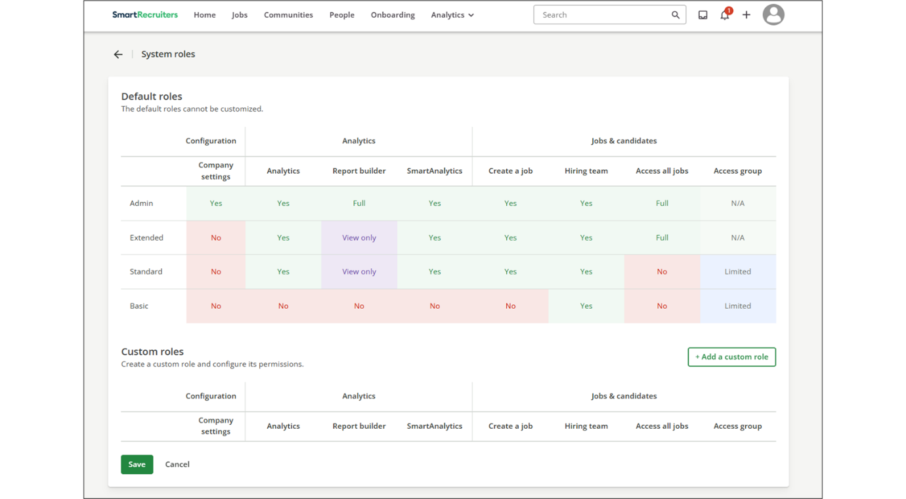
Default System Roles
Within SmartRecruiters, there are five default roles created within each system.
Permissions are automatically granted to each of these roles for recruiting-related actions and functions. It is critical to understand what the users assigned to this role can and cannot do.
- Admin Role: This is the highest level of system access. An admin can access everything in the system, including all core functionalities, data, and critical system configuration and company settings.
- Extended Role: This role is nearly identical to the admin role but with one key restriction: the extended user cannot access the system configuration or company settings. However, they still have full access to recruiting data, jobs, analytics and dashboards for data consumption, but they cannot create reports within the dedicated Report Builder tool.
- Standard Role: This user has a high level of operational functionality but restricted system access. A standard user cannot access the system configuration but can view all analytics and shared reports. Importantly, they have the permission to create new jobs. Their data access is limited, requiring them to be added to a hiring team to view a job or in an Access Group to see relevant candidate pipelines.
- Basic Role: This is the most restricted operational role (besides the passive Employee role). A basic user has no access to configuration or analytics. Like the standard role, the basic user can only access jobs and candidates when explicitly added to the relevant hiring team or an Access Group.
- Employee Role: The employee role is not listed in the System Roles list, as the system will automatically provide permissions to the Employee Career Portal to this system role. This is the only recruiting-related permission that is granted to the employee role and therefore, is not listed in the list of system roles.
Custom System Roles
Custom System Roles allow organizations to create up to 10 new custom system roles with specific, granular permissions tailored to unique business needs that the default roles do not cover. This provides flexibility and ensures data security and compliance by limiting access only to what a user needs to perform their job.
For example, let’s say that a Human Resources Business Partner (HRBP) needs to be able to create reports for jobs and access analytics, but does not need to create jobs and only needs access to certain jobs and candidate data for a specific business unit in a region. This would be a great example of when a custom System Role is needed, as these requirements are not met with the standard System Roles.
When creating a custom role, you will be able to manually assign permissions in the following categories to control access to recruiting-related features and information.
Permissions are typically broken down by module or entity (for example, Candidates, Jobs, Reports, Configuration) and by action:
- Company Settings
- Analytics
- Jobs and Candidates
Category | Description | Permission Types
Company Settings | Control the individual system-related actions and functions a user has access to: | - Administration  - Career Page Setup  - Templates  - Configuration  - Permissions  - Job Advertising
Analytics | Control the types of reports that a user can have access to. | - Report Builder  - Smart Analytics
Jobs & Candidates | Controls the recruiting-specific job and candidate data that a user has access to.  Access Groups allow further filtering of location or organization-specific permissions to be applied to a role. | - Create a job  - Hiring Team  - Access All Jobs  - Access Group
The following permissions can be assigned to the role for each permission:
- No (None)
- View Only
- Limited
- Full
Overview of Permissions for Each Permission Category
Analytics Permissions
Controls the level of access to the Sourcing, Candidate Pipeline, and Hiring Plan dashboards, plus the Analytics Reports.
Permission Type | Description
No | Cannot access Analytics dashboards or Analytics Reports
Yes | Can access all four Analytics dashboards and Analytics Reports
Report Builder
Controls the level of access to the reports generated by an admin with Report Builder.
Permission Type | Description
No | Cannot access Report Builder or read/download the generated reports.
View Only | Cannot access Report Builder or create new reports, but can read and download any reports that are shared with them via an Access List.
Full | Can create, delete, edit and download reports with Report Builder, and share with others.
Create a Job
Controls the ability to create, edit, and cancel jobs and use the Marketplace.
Permission Type | Description
No | Cannot create a job or access the Marketplace via the link in the top navigation bar.
Yes | Can create a job and access the Marketplace via the link in the top navigation bar.
Note
Marketplace access can be removed from the Menu for all users via the Marketplace Control in the Settings.
Hiring Team
Permission Type | Description
Yes | Can access a job and its candidates if part of the hiring team.
Note
All system roles can be added to a hiring team. If a user with the system role Employee is added to a hiring team, they are automatically converted to the Basic system role. However, when/if they are removed from all hiring teams, the system will not convert them back to Employee.
Access All Jobs
Controls access to all jobs.
Permission Type | Description
No | Must be part of a hiring team to access the job and its candidates.
View Only | Can access a job and its candidates, and view only some information, but take no actions (unless the user is a member of the hiring team or Access Group).
Limited | Can access a job and its candidates, view some of its information, and take some actions (unless the user is a member of the hiring team).
Full | Can access all jobs and candidates, view all of their information, and take any action on jobs or candidates.
Access Groups
Controls access to a job and its candidates as a member of the Access Group.
Permission Type | Description
No | Cannot access a job or its candidates if a member of the Access Group.
View Only | Can access a job and its candidates if a member of the Access Group; can view limited information, but cannot take actions against the job or its candidates.
Limited | Can access a job and its candidates, view some information, and perform some actions on the job and its candidates if the user is part of the Access Group. If set to Limited, this permission will supersede Hiring Team Role permissions for users who are members of the Access Group.
Full | Can access all jobs and candidates, view all of their information, and perform all actions on the job and its candidates if a member of the Access Group.
Create a Custom System Role
Creating a custom system role allows organizations to create customized permissions for a user group.
To add a custom system role:
Steps
- On the SmartRecruiters home page, click User Menu→Settings.
- In the Permissions section, click System Roles.
- In the Custom Roles section, click + Add a custom role.
- Enter the name of the role. This new role will show up as an option in User Management when adding a new user.
- For each area, choose the level of permissions for that role.
- Click Save.
Assign System Roles to Users
Once all permissions are configured, the new role can then be assigned to users individually to manage those specific permissions. The assignment process ensures that each user has the correct level of access to perform their specific job functions. This process ensures that a company can closely align system access with its organizational structure and security requirements.
To assign a user a role:
Steps
- On the SmartRecruiters home page, click User Menu→Settings.
- In the Permissions section, click User Management.
- Find the user you wish to modify in the list of users.
- To the right of their name and email, select the pencil icon.
- Under User role select the role you wish to assign to the user.
- Click Save.
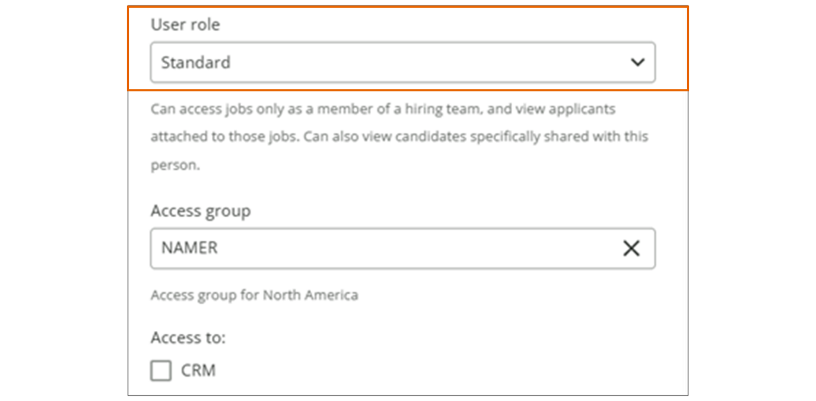
Summary
- SmartRecruiters uses a two-level role structure: System Roles (defining system-wide access) and Hiring Team Roles (defining access to specific jobs and candidates).
- Default System Roles (Admin, Extended, Standard, Basic, Employee) provide preconfigured permission sets for common user types.
- Custom System Roles allow organizations to create roles with granular permissions tailored to unique business needs, enhancing data security and compliance.
- Custom roles can be configured with varying levels of access to Company Settings, Analytics, and Jobs & Candidates, using permissions like No, View Only, Limited, and Full.
- System Roles are assigned to users via User Management in Settings, controlling their access to features and data within SmartRecruiters.
Creating Access Groups
Objective
After completing this lesson, you will be able to create and assign access groups to manage permissions and data visibility.
Overview of Access Groups
In SmartRecruiters, controlling access to sensitive data and functionalities is crucial for ensuring that the correct users have access to the correct jobs, candidate data, and areas of the recruiting system. Access groups provide a flexible way to manage permissions for users with specific system roles.
The use of access groups with system roles provide customers with a vital tool for managing user permissions and ensuring data security. They allow administrators to define specific levels of access for different system roles within the organization.
When thinking of the overall permissions granted to a user, you will have to consider both the system role, and whether an access group is needed.
Feature | System Role | Access Group
Definition | A predefined set of permissions or capabilities (examples: create a job, edit a candidate, access settings). | A dynamic layer of permissions applied to a system role, defined by specific org fields(examples: country, department).
Example | - Admin  - Extended  - Standard  - Basic | - All Sales Jobs in France  - All IT Jobs in North America  - All Jobs for Brand X
Control Level | System-level access and feature permission. | Filtered visibility and specified access.
Note
Remember, default and custom system roles define system-level access to jobs, hiring team and analytics.
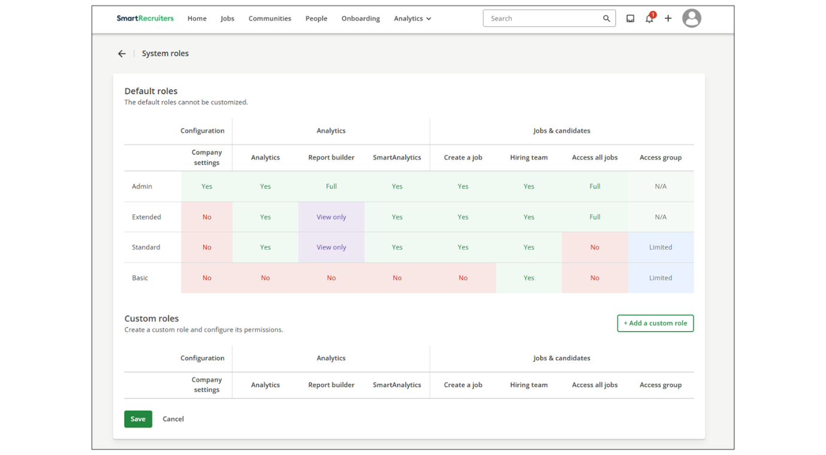
In many cases, recruiters don’t need access to all jobs, but just those that they are responsible for, such as line of business or business unit. Using access groups, a layered filter of permissions can be applied in addition to the system role that a user receives. Access groups can be used for default (except for Admin and Extended) and custom system roles defined in the system.
For example, a recruiting user can be assigned the default system role of Standard, which gives them the ability to create jobs, and access to hiring teams and certain analytic features). However, the Standard role, by default, does not grant permissions to all jobs. Without an access group assigned, this recruiter would only see jobs for which they are added to the applicable Hiring Team. If the access group is set to Sales jobs in France, the recruiter can see all jobs and applicants for the jobs where they’re on the Hiring Team, in addition to all other sales jobs located in France.
Example use case:
A company operates in the market under three different brands- A, B and C - in 2 different countries - Germany and France. Each brand has assigned recruitment teams by country who should only be able to access jobs in their own country and brand. To achieve this, 6 access groups would have to be created to match this criteria:
- Access group 1 - Company A, Germany
- Access group 2 - Company A, France
- Access group 3 - Company B, Germany
- Access group 4 - Company B, France
- Access group 5 - Company C, Germany
- Access group 6 - Company C, France
Let's now consider that, for each country, there's a head of recruitment activities that needs to have access to all jobs in that country regardless of brand or any other criteria. This would require 2 more access groups, one per country. Each access group would then need to be assigned by an admin to the correct user(s) via the user profile.
If a user is given multiple permissions on the same job(s), the highest permissions will be granted. For example:
- If User A has limited access to all jobs, and full access to Sales Jobs in France, the user will have access to all jobs under that access group and limited access to the remaining jobs.
- If User B has limited access to all jobs, and view only access to Sales Jobs in France, the user will still have limited access to all jobs.
Limited Permissions
Limited permissions allow a user to see the following information for jobs and candidates:
Jobs List Tab
Can | Can't
Filter jobs | Edit, publish, share, cancel, or delete jobs
See job location | Make referrals
See open dates | Send to Agency
See job statuses
See ref numbers
Individual job page
Can | Can't
See job location, date, status, and link | See jobs details
See basic sourcing info | See candidates comparison
See applicants list, activity, job ad, hiring process and interview tabs | Send to agency
Filter candidates | Edit, publish, unpublish, share cancel, or delete a job
See candidate name, title, source, job and status | Edit Hiring Team or Scorecard
Email, share, or invite candidates | Reject, defer, delete, hire, or mark candidate as withdrawn
Reassign or add another job
Add candidate
Compare candidates
Remove from job
See or leave ratings
People List Tab
Can | Can't
Filter candidates | Defer or delete candidate
See, candidate name, title, job applied to, status | Merge candidate profiles
See date added to system and last updated date
Add to job
Add candidate
Candidate profile
Can | Can't
See and edit contact information | Move candidate through hiring process
See emails and email candidate | Defer, reject, delete or mark as withdrawn
See notes and leave notes | Send to agency
See reviews and scorecards, leave ratings, fill out scorecards | Edit, publish, unpublish, share, cancel or delete job
Add to another job | Edit Hiring Team or Scorecard
See profile, tags, application fields | See offers or extended offers
See and edit application fields
See and add attachments
See screening questions answer
Schedule interviews
Reassign or remove from job
Watch the video on Creating Access Groups for more detailed information!
This video is for demonstration purposes. Any references made in this video to previous or later videos in this course (including titles, numbers, links, or sequence) may differ from the current course structure. Additionally, some functionalities shown may have evolved over time due to ongoing enhancements or business decisions.
Create an Access Group
Steps
- Navigate to Settings.
- Within the Permissions category, select Access Groups.
- Select Create group.
- Provide the group information, including:
  - Access group name
  - Short Description
- Within the configuration section, select the appropriate organization information to define this access group.
Example
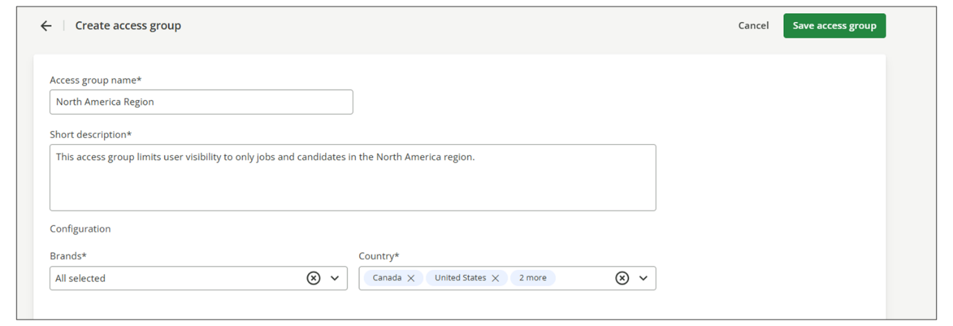
Assign Access Groups to a User
Steps
- Navigate to Settings.
- In the Permissions section, select User Management.
- Find the user you wish to modify in the list of users.
- To the right of their name and email, select the pencil icon.
- Under User role, select the role you wish to assign to the user.
- Click Save.
Best Practices When Working with Access Groups
- Regularly Review Access Groups: Periodically review access groups to ensure that they still align with the organization's needs and security policies.
- Use Descriptive Names: Use clear and descriptive names for access groups to make them easy to identify and manage. Deciding on a naming convention format also helps future Access Groups Management.
- Minimize Overlapping Permissions: Avoid assigning overlapping permissions to users to prevent confusion and potential security risks.
- Document Access Group Policies: Maintain documentation outlining the purpose and permissions of each access group for reference and auditing purposes.
Summary
- Access groups in SmartRecruiters provide a way to manage permissions and data visibility for users with specific system roles.
- Access groups act as a dynamic layer of permissions, filtering access based on organizational criteria such as country or department.
- System roles define what a user can access, while access groups determine the jobs and candidates they can access.
- When a user is assigned multiple permissions, the highest level of permission is granted.
- Best practices for Access Groups include regular reviews, descriptive names, minimizing overlapping permissions, and documenting policies.
In this video, we're going
to look at how to create and assign access groups to
users in SmartRecruiters. There are two different ways you
can use access groups. The first way I'm going to show you is how to assign
an access group that allows basic and standard users to have more
visibility into jobs in your system without those users having to be
assigned to a hiring team. For example, say I have a standard or basic user
who's a recruiter and I need that recruiter to be able to see all jobs
posted in the UK but I don't want to have that user have to be added
to the hiring team for each one of those jobs. So the way we accomplish
this is adding them to an access group. Now if they are a basic or
standard user if they are added to an access group they will have
limited access to what they can do with the jobs that they can see that
fit into that access group. If I come down here to show you what
limited means if a standard or basic recruiter can view a job because of
the access group they're assigned. They can only perform some actions
on the jobs and its candidates, not all actions like an admin or extended
user. If you had a recruiter in a custom role, you could give them
full access to jobs that fit within their access group. But for this
example, we're going to be talking about a user that has either the
default standard or basic system role. If under the limited access for
an access group you can check out system roles in our Help
Center. So like I said for this scenario I have a recruiter with
standard access that needs to be able to see all jobs posted in
the UK but I don't want to have users have to add that recruiter
to the hiring team for every single job in the UK. So in
order for this recruiter to be able to see all the UK jobs I'm
going to create an access group that will allow him to do so.
So to create an access group, you go to Settings and Admin, and then under Permissions, click Access Groups. So I already have a couple
access groups created, but I don't have anything that
will allow users to only see jobs in the UK, so I'm
going to create that now. So I'm going to click
Create Group, give my access group a name, and
then also a description. It's best practice to add a
short description to your access groups so other users know
what that access group is for. Underneath Configuration,
you'll see my org fields. To learn more about org fields, you can check out our tutorial
on job and org fields. So like I said in this
scenario, I only want the user to see jobs in the UK, so
I'm going to be using the country org field here. I'm
going to unclick all and I'm going to scroll down and
just choose United Kingdom. I could add other criteria if
I needed, for example, if I only wanted this recruiter to see
sales jobs in the UK or only full-time jobs in the UK I could add
that criteria here as well but for right now this recruiters
just going to be able to see any job posted in the UK. I'm
going to save this access group. The other way an access
group can be used is when you're working with
a delegated admin role. So I'm going to go back
to my system roles. And how an access group works with
a delegated admin is that depending on what the delegated admin has
as far as what company settings they can edit, the access group
in that scenario is going to make it so that that delegated admin can
only perform those administrative tasks on jobs that fit within
the access group. So for example, my delegated admin that I have
that can edit templates on jobs. If I come in here and look at the
company settings, this delegated admin can go in and edit email
templates, offer templates, and also edit screening questions. But
maybe I want this particular user to only edit those templates and
screening questions on UK jobs. So in that case, if I assign
that UK access group to this delegated admin, they'll
only be able to perform those actions on the jobs that
fall into their access group. So if I go back to my access groups, and I maybe wanted to edit this
access group to also call out that this is for delegated admins
in the UK as well. I can click edit and I can add that to my
group name and to my description. I also want to note that you
can't use special characters in an access group name so I had to
use the word and instead of an ampersand. And now I'm going to
save this. I'm going to leave my description the same and then to
assign an access group to a user you're going to go back to your
settings and admin user management and so here I can actually
search by system role so I quickly just want to see all
of my users with standard. I'm going to go to Lila here
I'm going to click edit and this is where I'm going to
assign that access group. I want to note that a user
can only be part of one access group at a time and cannot be
part of multiple access groups. I also want to add the access group
to my user that has the delegated admin email template role so I
can search by that here and when I click on Lynette's edit I can
add her to the access group as well. So again a standard and basic
user adding them to access group will allow them to see jobs and
perform limited actions on jobs that fall within that access group.
Whereas a delegated admin, they are added to an access group, they
can only perform the admin tasks that they're assigned to jobs that
fall within that access group. Thank you for watching
this video on creating and assigning access
groups in SmartRecruiters.

Setting Up Delegated Administrators
Objective
After completing this lesson, you will be able to configure delegated administrator roles and permissions to manage user access effectively.
Introduction to Delegated Administrators
The purpose of creating a Delegated Admin in SmartRecruiters is to distribute administrative responsibilities and reduce the burden on a single, global Super Admin. This is a critical security and efficiency feature for large, decentralized organizations.
This solution extends custom system roles and allows administrators to specify when a custom system role is being used as an admin role, one that has lesser privileges.
Imagine your HR department is growing, and you need to distribute some administrative tasks within SmartRecruiters without granting full access to the entire system. Delegated administration allows you to grant specific permissions to users, enabling them to manage certain aspects of the platform, such as managing users in specific departments or locations, without compromising overall security.
Purpose of Creating a Delegated Admin
The core purpose of the Delegated Admin feature is to:
- Enhance Security and Minimize Risk (Principle of Least Privilege): By delegating specific, limited administrative tasks, the organization avoids granting full, unrestricted admin access to multiple people. This protects sensitive global configuration settings and financial information.
- Enable a Multi-Tier Admin Model: It allows the organization to build an administrative structure based on organizational criteria such as location, business unit, or role. This ensures local HR, TA leaders, or IT personnel can manage their own teams.
- Improve Operational Efficiency: It empowers local or regional administrators to manage day-to-day user tasks (like onboarding new users or resetting passwords) without having to wait for a centralized admin, accelerating local hiring processes. By distributing administrative authority, the system's day-to-day functioning is not dependent on a single individual, preventing bottlenecks when the admin is unavailable.
In essence, Delegated Admin allows an admin to selectively turn on or off access to specific administration configurations and features for a trusted user group.
Watch the video below for more details on creating Delegated Administrators.
This video is for demonstration purposes. Any references made in this video to previous or later videos in this course (including titles, numbers, links, or sequence) may differ from the current course structure. Additionally, some functionalities shown may have evolved over time due to ongoing enhancements or business decisions.
Create a Delegated Admin
Steps
- Navigate to Settings.
- In the Permissions section, select System Roles.
- Select Add a Custom Role.
- Name the role Super User (or any other name that is relevant and compliant to the organization standards and naming conventions) and make configuration selections in each column and select Save.
- Select the Company Settings icon.
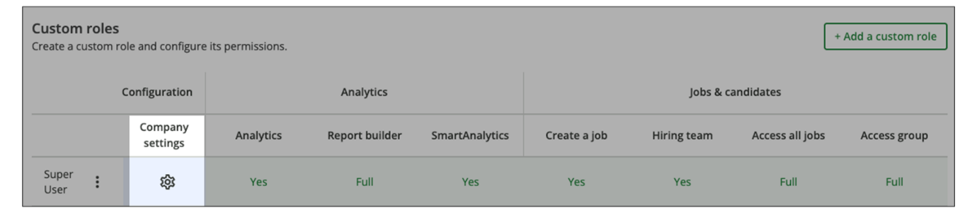
- Enable the switch titled: This is an administrative role.
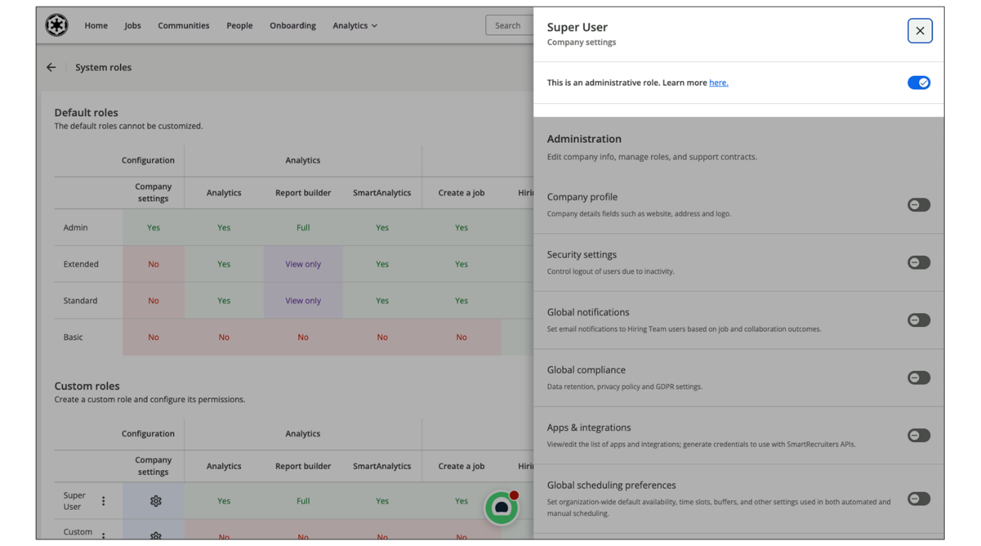
- Features toggled on in the individual Company Settings fields will be accessible to the Delegated Administrator in the Settings menu. Features not toggled will be grayed out and inaccessible.
- Assign this new custom role to the intended user(s) via Settings→User Management→Edit User, select the pencil icon on the right-hand side of the name and email address, and select the correct custom system role from the User role dropdown.
Influence of Access Group Configuration on Delegated Admins
The following features do respect Access Group configuration:
- Communication Templates
- Auto Replies (both internal and external)
- Offer Templates
- Custom Consent Request
- Screening Questions.
The company is operating in the UK, Spain and Taiwan. The email templates, screening questions, offer templates, and so on, are configured by country (based on org fields) for these countries: UK, Spain, Taiwan. A delegated admin user was assigned an access group for the UK.
Therefore, the Delegated Admin (considering that those settings have been toggled on for the delegated admin system role) will be able to access only UK templates and will not see the templates for Spain and Taiwan.
The following features do not respect Access Group:
- Job Approvals
- Offer Approvals
- Candidate Fields
- Hiring Process
- Career Pages & Job Ad
- Job Ad Footers
Note
All the rest of the features not listed in the above list do respect Access Group.
So, if the client decides to give access to Apps and Integrations or Company Profile (for example) then the client usually has a specific governance around configuration settings shared across all admin/delegated admin.
If you toggle on the Application fields/Candidate fields admin permission for the delegated admin, then the user will have access to the entire configuration for all three countries: UK, Spain, and Taiwan, even if some of the candidate/application fields are configured for only the UK.
If you toggle on the Hiring Process admin permission for the delegated admin, then the user will have access to the entire configuration of hiring processes, not only the one created for the UK.
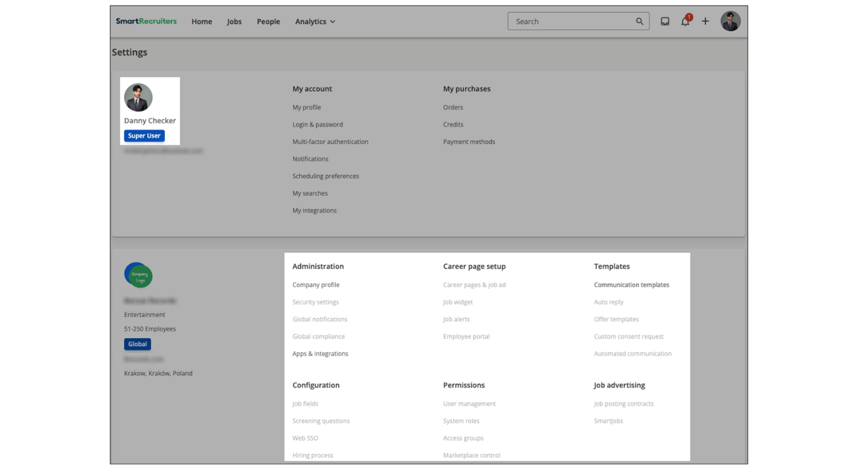
Summary
- Delegated Administrators in SmartRecruiters distribute administrative responsibilities, reducing the burden on a single Admin, which enhances security.
- The Delegated Admin feature allows for a multi-tier admin model based on organizational criteria like location or business unit.
- Creating a Delegated Admin involves creating a custom system role and enabling the This is an administrative role setting.
- Specific administrative configurations and features can be selectively enabled or disabled for Delegated Administrators.
- Delegated Administrators can manage certain aspects of the platform, such as users in specific departments or locations, without compromising overall security.
In this video we're going to
be looking at how to create a Delegated Admin custom
role in SmartRecruiters. A Delegated Admin role is a custom
role that gives a user specific admin permissions without making them
a full admin user. For example, I have a Delegated Admin role for a
user from our legal team who needs access to a few company settings that
involve security and legal options. To view the admin permissions
granted for this role, I can hover over the role
and click Company Settings. As you can see here on the
Administration page, this role has access to Security and
Global compliance settings, as well as offer templates
and a few other permissions. I want to note that not
every admin permission has the ability to be toggled
on or off on this page. The toggle at the top that says this
is an administrative role allows a delegated admin to have a set
of permissions not listed here. To see what permissions are
part of the administrative role you can click to view the
permissions listed on our Help Center. These permissions mainly
relate to jobs and candidates and if your delegated admin
role will need access to any of these permissions then you'll
want to turn this toggle on. For the delegated admin role I want
to create today I'm going to click add a custom role and create a role
for a user who will be responsible for creating email and offer templates
as well as screening questions. I'm going to put in the name of my role. I'm going to click Save. You'll notice that when I was
creating the role for the first time I didn't have an option to turn
on or off the company settings. You first have to save the
role when you create it and then hover over it
and click the Company settings icon to go toggle
on and off your settings. So like I mentioned this role is
going to be for a user who's going to be logging into SmartRecruiters
and have the ability to edit and add email templates as well as screening
questions for jobs. So I'm going to bypass these settings here as I
don't need them and go down to my template section. I'm going to
toggle all of these on for this role. I also want to make sure I have screening questions toggled on as well. And there's no save button.
You simply click the system roles link to go back
to your system roles page. Now you see on my email templates user that under configuration it says limited. If I wanted to, I could also add
access to analytics or the ability to create a job, but for right
now I'm going to leave it as is. I also want to point
out the use of access groups in regards to delegated admins. Using the role I just created, if
I wanted to give this role full permissions if added to an access
group. I can change that here and then what will happen is
that this user will only be able to do the actions that I've toggled
on for them in company settings only for jobs that they can
view as part of an access group. So for example if I wanted this
email template user to only be able to edit templates
and screening questions for jobs located in the UK then I
can add them to an access group that allows users to view
and edit jobs only in the UK. Another way to think about this
is that adding a basic or standard user to an access group essentially
gives them more access and that they can now view and edit jobs
that are part of that access group. While adding a delegated admin
to an access group limits their admin functions to only the jobs
in their assigned access group. You can learn more about access groups
in our Access Group tutorial.

Creating User Accounts
Objective
After completing this lesson, you will be able to configure new user accounts with appropriate roles and permissions.
Roles and Permissions
Setting up users in SmartRecruiters is a fundamental administrative tast that allows you to grant access to the recruiting platform to team members, hiring managers, and other stakeholders, including employees, in order to allow them access to the internal career site where referrals can be made. Assigning the appropriate role is part of creating a user.
By assigning specific roles and permissions, you can ensure that each user has the appropriate level of access to perform their job functions while maintaining data security and compliance. When creating a user within SmartRecruiters, you will need to assign them a System Role, and Access Group (if necessary/applicable) which will determine what the user can access, see and do within the SmartRecruiters system.
Users can be created manually, uploaded in bulk or via a user integration.
Add Users Manually in SmartRecruiters
Each individual user in SmartRecruiters has a user profile, which combines their personal information, as well as login and password information. After being added to the system, each user will be able to set their own email, scheduling and notification preferences, amongst other options.
Steps
- Navigate to Settings→User Management.
- Select Add New User.
- Provide the following mandatory information:
  - First name
  - Last name
  - Email address
- Choose the login method: SSO or Email & Password.
- Assign a System Role to the user:
Use a drop-down menu to select from the list of default and custom system roles.
- Select an Access Group (if applicable).
- Save your changes.
Note
If the portal has CRM, Pre-boarding, Candidate Messaging or other add on enabled, it's also within the user profile that access to these tools can be provided by selecting the desired option.
Watch the video below to learn more!
This video is for demonstration purposes. Any references made in this video to previous or later videos in this course (including titles, numbers, links, or sequence) may differ from the current course structure. Additionally, some functionalities shown may have evolved over time due to ongoing enhancements or business decisions.
Add Users in Bulk in SmartRecruiters
Steps
- Navigate to Settings→User Management.
- Select Bulk Manage on the top right-hand corner.
- Download the template.
- Fill in the template with at least the mandatory fields: firstname, lastname, email, systemRole. The format of this file should be CSV.
- Upload the file by selecting the upload CSV button on the top right-hand corner of the same screen from where you've downloaded the template.
Select the file from your computer or drag and drop.
Add Users via a User Integration
Steps
- Navigate to the Apps & Integrations menu.
- Generate an API key.
Summary
- Roles and permissions are necessary to give each user the appropriate access level to perform their job functions, while maintaining data security and compliance.
- System roles determine the level of access a user has within SmartRecruiters. You can select from a list of default and custom roles.
- Access groups can be assigned to further refine user permissions.
- Users can be created and managed via three different ways: manually, bulk upload or user integration.
Hi, in this video we're going
to look at user management in SmartRecruiters. So, to
view all your users in SmartRecruiters, you're going to go
onto your Settings and Admin page and then click on User
Management under Permissions. Here you'll see a list of all
your active and deactivated users. As you can see by the toggle, an
active user is toggled on which is green and then a deactivated
user is grayed out here. If I just want to see my active
users I can click on the filter over here on the left and this
will show me only active users. You also can search for users by name and your other filtering options
include filtering by system role, by access group, if you have additional
smart products, who has access to what modules, and also you can
filter by the type of sign-on the user has. So for example if I want
to see just all my admins in the system I would just choose Admin
here and these are all my admins. You can choose multiple
filters at one time so if I want to see both admin and
extended users I can just click extended as well and
you'll see up here it's going to let me know what filters
I have currently applied. To remove your filters you can
just click the X and the same steps apply to filtering by access group,
by module, or by the sign-in. There are a couple ways to add a
user to your system. You can add a user manually by clicking the add
new user button or you can do a bulk upload of users using the Bulk User
Upload button. You can check out more on how to use the bulk user
upload in our bulk user upload feature tutorial. For this example I'm going
to just add a new user manually so I'm going to click the Add new
user button and I'm going to give my user a name and an email and it's
important to note that for email each user's email has to be unique
to the SmartRecruiters system so for example if during your
implementation you had a sandbox account and you used your email while doing
your testing, once you move over to your production system if you try
to use that email to create a user in that system it will say that
user already exists so if you do enter an email and it says the user
already exists but you know they're not in your production system, you
can reach out to our support team and they can help find out where
that email is being used. You also can choose the language preference
for this user when they enter the system. And keep in mind that once
the user logs in, they can also change their language preference as
well. And then you're going to choose a sign-in option. If you do not
have SSO enabled for your system and you choose the Single sign-on
button here which is defaulted to be on. You'll see this notice here
saying that you can't use single sign on because you don't have it
activated for your system. So in this case you would choose the email and
password. If you do have Single sign on and you want this user to be
able to sign in via the Single sign on you would choose that here. But
if you do have Single sign on and maybe you have a user that is not
in the active directory and they will need to be logging in, you can
set up email and password for a user as well even if you do have Single
sign-on enabled for your system. So since I don't have Single
sign-on in this instance I'm going to be using email
password as the login and then you're going to choose your
user role. It is required that every user in the system
has a system role assigned and you'll notice if I make this
user an admin user the access group drop-down disappears. That's
because the system roles of admin and extended aren't applicable
to have access groups because you already have full access to all jobs
and candidates in the system. So you will not need an access group
assigned. But if you choose a standard, basic, a delegated admin,
or one of your custom roles that can be assigned an access group,
you'll see the access group here. So I'm going to make this user
just standard user and I'm going to assign them to my UK recruiters
access group. It is important to note that users can only be
assigned one access group at a time. It is not possible for a user
to be in multiple access groups and then if I wanted this user
to have access to any of my other modules purchased I can click
that here so if I want to give this user access to the CRM, I
can and what's going to happen is that this is going to send an invite
to this user to activate their profile and SmartRecruiters so
I'm going to click send invite now if that user goes to their
email they will see their invite to login to SmartRecruiters and
they can create their password. I want to note here that if
you've added a user and you've sent the invite and then
later you want to add that user to a hiring team but their
email isn't coming up it may be because they haven't
actually activated themselves. So a user that is active
is a user that is actively in the system as we saw in
the User management screen. An activated user is a user
that has come in, accepted the invite, and created their
profile within SmartRecruiters.

Creating Hiring Team Roles
Objective
After completing this lesson, you will be able to create and assign Hiring Team roles.
Hiring Team Roles in SmartRecruiters
The primary use of Hiring Team roles is to define which actions each user can perform at job and candidate level during the hiring process for a specific opening. Hiring Team roles in SmartRecruiters are essential for defining responsibilities and driving the workflow for a specific job requisition.
It is important to understand the difference between a Hiring Team Role and a System Role.
Hiring Team Roles and System Roles Comparison
Feature | Hiring Team Role | System Role
Scope | Job-specific. Assigned for a single job requisition. | Global. Assigned to the user's profile and applies across the entire platform.
Purpose | Defines a user's access and permissions in the hiring process of a specific job. | Defines a user's capabilities and access across the entire platform (for example, access to settings, reporting).
Example | Hiring Manager (for the Marketing VP job). | Admin or Recruiter.
Assignment | Set on the job requisition. | Configured in Settings→User Management.
Note
For those familiar with SAP SuccessFactors, Hiring Team Roles are known as Recruiting Operators in the SAP SuccessFactors Recruiting solution.
When someone adds a user to a hiring team, they assign the user a Hiring Team Role that determines:
- the user's level of access to certain information about the job and candidates on that job
- the actions the user can take on the job or candidate, such as extending an offer or editing the job’s details
Types of Hiring Team Roles
Hiring Team Roles can be categorized into two high level types:
- Standard/Default Hiring Team Roles: These are the five Hiring Team Roles that appear in the Hiring Team Roles Configuration menu. They come with out-of-the-box permissions, but, other than their names, are fully configurable.
- Additional Custom Roles: Consists of a maximum of five additional roles that you can create and configure to your liking. They are fully configurable from the Custom Roles menu, including their role name.
Standard/Default Hiring Team Roles
There are five standard/default Hiring Team Roles that are pre-built into the SmartRecruiters system.
Standard Hiring Team Roles
Standard Hiring Team Roles - Types | Standard Access and Permissions
Hiring Manager | The default Hiring Manager role gives users full access to the job and candidates who apply to the job, and they can perform all job and candidate actions without restriction.
Interviewer | The default Interviewer role grants the most limited level of access. This role is only able to view candidate profiles and resumes, and rate and compare candidates.
Recruiter | The default Recruiter role gives users full access to the job and candidates who apply to the job, and can perform all job and candidate actions.
Executive | The default Executive role gives users full access to the job and candidates who apply to the job, and can perform all job and candidate actions without restriction.
Coordinator | The default Coordinator role gives users full access to the jobs they are assigned to, but they have limited access to candidates who apply to that job. They can't advance candidates through the hiring process, extend offers, or reject.
Essentially, Hiring Team Roles exist to help companies manage users with Standard and basic system roles, and give them different levels of access and permissions on each job for which they are part of the hiring team.
Users with Admin or Extended system roles have full access to jobs and candidates, no matter what hiring team role they have. Their system role takes priority over hiring team roles.
In many organizations, there may be other individuals involved in the hiring process such as an HRBP. AS previously mentioned, in SmartRecruiters, you can build up to five additional custom Hiring Team Roles as needed.
Actions and Access Levels
The permissions assigned to a Hiring Team Role in SmartRecruiters are narrowly focused on job-specific actions and candidate access for that particular requisition. They determine what a user can do with the job and its candidates, rather than their global access to the system.
The process of assigning Hiring Team Role permissions requires understanding the action that is being permissioned, and the access level to that action. Each action can have a different access level to ensure that the right roles have the access to perform the appropriate actions.
Actions
Each custom and default hiring team role's permissions is defined as a list of actions they can or cannot perform about the job or candidates on the job.
For example, job actions include:
- Publishing/unpublishing/cancelling a job.
- Editing the job's status manually (without moving the candidate forward or back in the process.
When added to a job's hiring team and assigned a role, the user is assigned the role's list of allowable actions for that job and any candidate applications to that job.
Access Levels
Each role is assigned an access level for each action. The access level determines exactly what a user who is assigned that role can do in relation to that action.
Some actions have three levels (for example creating and sending offer for approval or sending to candidate):
Access Levels - Table 1
Permission Type | Description
Write | User can see and modify information.
Read | User can see but not modify information.
None | User cannot see or modify information.
Others have four (for example, reviews of the candidate):
Access Levels - Table 2
Permission Type | Description
Write | User can see previous reviews and write reviews.
Write only | User can only own previous reviews and write reviews.
Read | User can see the reviews tab but cannot write a review.
None | User cannot see the review tab at all.
Others have only two (for example, requesting the consent from the candidate and the status of that consent):
Access Levels - Table 3
Permission Type | Description
Yes | User can perform this action.
No | User cannot perform this action.
Modify Default Hiring Team Role Permissions
Through the Hiring Team Roles menu, admins can precisely configure and customize the access and actions granted to existing or additional Hiring Team Roles.
Steps
- Navigate to Settings.
- Within the Permissions section, select Hiring Team Roles.
- Within the Configure Default Roles tab, you will find a table displaying the default Hiring Team Roles and permissions assigned to two categories: Job and Candidate.
- Find the permission you would like to modify for a Hiring Team Role.
- Select the pencil Edit icon.
- Choose the role's Access Level for that action from the list.
- Select Save.
Note
Changes take effect immediately.
Create a Custom Hiring Team Role
To create a custom hiring team role:
Steps
- Navigate to Settings.
- Within the Permissions section, select Hiring Team Roles.
- On the Additional Roles tab, select Manage additional roles.
- Select Add a role.
- In the Name field, enter a name for the role.
- Select Save.
- When you create a new role, SmartRecruiters defaults all of the role's Access Levels to None, No, or Read as appropriate for each action. In the Job and Candidate Actions tables, go through each action and assign an Access Level by clicking on the pencil Edit icon and choosing an access level from the dropdown menu that appears.
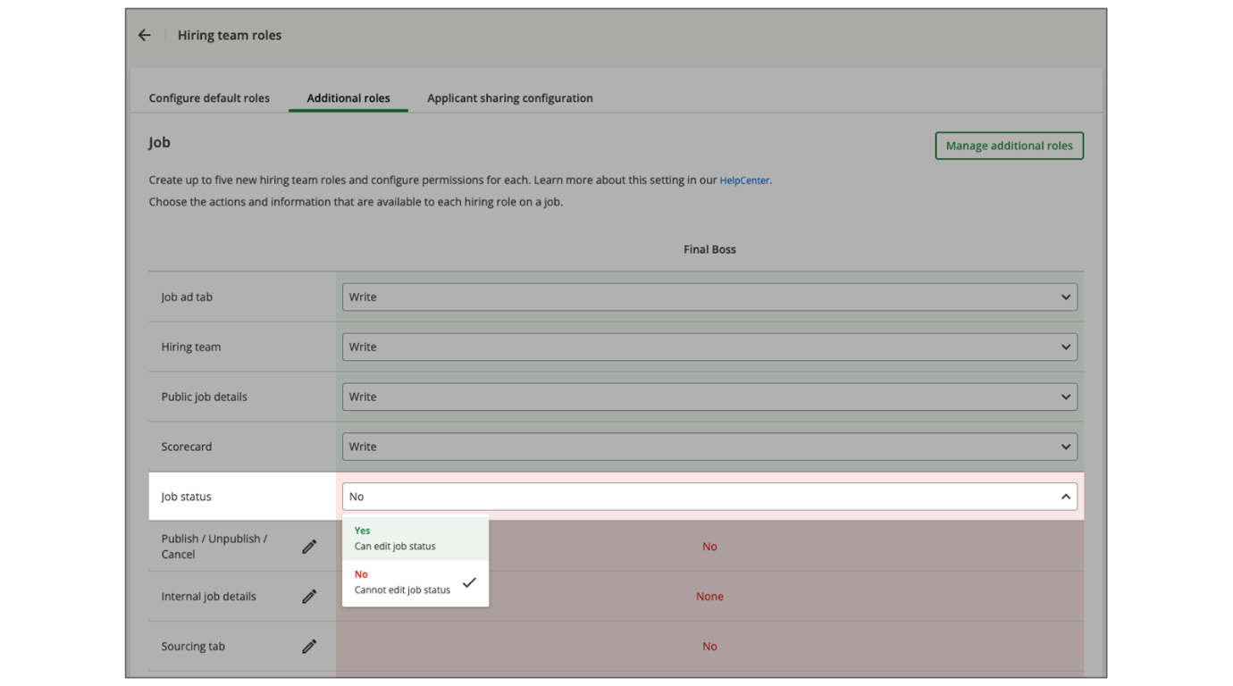
- Select Save.
Assignment of Employees to a Hiring Team Role
Once a user is added within the job to one of the Hiring Team roles, the role will determine which job-specific actions they can take and the job or candidate-related data they can see within the job.
The hiring team can be added to the job when it's created and can be modified at any time. When creating a job, it's always mandatory to add at least a Recruiter or a Hiring Manager to the hiring team.
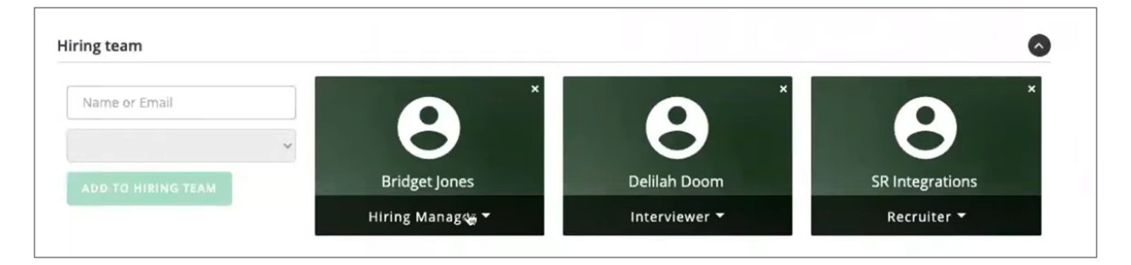
Example Use Case: Configuring Hiring Team Roles for Company A Recruitment Strategy
The company HR team is implementing SmartRecruiters across the organization. Before posting any jobs, they need to define standard Hiring Team Roles that align with their recruitment governance model.
After analyzing their hiring process, they identify that their stakeholders typically include:
- Engineering Managers: Need full control over their technical hires.
- Technical Interviewers: Should evaluate candidates but not make hiring decisions.
- Recruiting Coordinators: Handle scheduling and logistics without candidate decision-making authority.
- HR Business Partners: Review compensation and approve offers but don't manage the day-to-day hiring process.
- Department Executives: Require visibility into senior-level hires for final approval.
Once the list of stakeholders has been developed, the admin team configures the system:
- They customize the five default roles (Executive, Hiring Manager, Recruiter, Coordinator, Interviewer) to match Company A's standard permissions.
- They create a custom HRBP role with:
  - Read access to candidate information.
  - Write access to offers and compensation.
  - Read access to reviews.
  - No (None) access to advancing candidates through stages.
Result: Now, whenever any recruiter creates a job requisition across Company A, whether for engineering, marketing, or finance, they can assign team members to these standardized roles, ensuring consistent permissions and responsibilities across all hiring processes company-wide.
Additional Notes
- Admins cannot deactivate an additional role if the role is currently being used in an existing approval chain.
- Admins cannot delete an additional role if there is at least one user assigned to that role on a hiring team.
- There are some inter-dependencies between actions. SmartRecruiters will resolve these inter-dependencies as needed. For example, assume an admin has granted a user Write permissions for Offers, but None permissions for Messages. The user will need to be able to send an offer, so SmartRecruiters will ignore the Messages permission. In the future, they may add de-confliction rules, but this is the current logic.
- SmartRecruiters will automatically update candidate status based on user actions, even if the user doesn't have the ability to edit status in following situation:
  - First email, message or review made on an application will move automatically the application from New to In Review – first step.
  - If Offer Accepted step is activated, when an offer is accepted by the user in the UI, the application will move automatically to Offer Accepted step.
Note
If workflows are enabled, the system behavior might be different.
Summary
- Hiring Team Roles clarify responsibilities for actions during the hiring process for a specific job, defining access to job and candidate information.
- Hiring Team Roles are job-specific, defining responsibilities within a specific job requisition, whereas System Roles are global, defining a user's capabilities across the entire SmartRecruiters platform.
- The five standard roles (Executive, Hiring Manager, Recruiter, Coordinator, Interviewer) come with pre-built permissions that can be customized.
- Admins can create up to five additional custom roles and configure them to your liking, including their role name and permissions.

